Original Article
International Journal of Engineering Practices and Applications
First Author
Author Affiliation
Second Author
Author Affiliation
Third Author
Author Affiliation

Abstract – This article gives the overall view of the articles published in International Journal of Engineering Practices and Applications. Abstract should be written in a motivate manner such a way it should make the readers to browse through the article completely. Abstract must be written with Times New Roman font with font size 10 and 150-200 words. Authors can make use of this template in preparing their final version of the manuscripts.
Keywords – List of Keywords that are used in the article should be written. All the keywords should be separated with commas. Minimum of five keywords must be written.
- Introduction:
This section serves as an introduction to the article and should clearly present the problem addressed throughout the paper. It should be written in a way that captures the reader’s interest and motivates them to continue reading. The manuscript must be prepared using Times New Roman font with a size of 12, following the provided template, which is mandatory for the final version of all accepted articles.
The International Journal of Engineering Practices and Applications (IJEPA) is a timely and dedicated scholarly journal that accepts only original and unpublished manuscripts. The journal publishes research articles, survey papers, and review articles in relevant engineering domains. All submitted manuscripts undergo a formal review process conducted under a single-blind peer review system, where reviewers are aware of the authors’ identities, but authors do not know the reviewers. Each submission is evaluated by a minimum of two reviewers, and editorial decisions are based on the received reviews. Authors are informed promptly once a decision is made. Upon acceptance, authors are required to transfer the copyright to the IJEPA journal.
- Related Work:
This section should provide a concise summary of all relevant studies conducted by previous researchers that are related to the current research problem. The text must be formatted using Times New Roman font with a font size of 12. Subtopics should be listed as specified below:
• Subtopic 1
• Subtopic 2
• Subtopic 3
All subtopics must be numbered correctly, as illustrated in the following format:
2.1 Subtopic 1
Each subtopic should be numbered sequentially and cited appropriately [3].
2.2 Subtopic 2
Each subtopic should be numbered sequentially and cited appropriately [4, 5].
2.3 Subtopic 3
Each subtopic should be numbered sequentially and cited appropriately.
- Proposed Methodology:
This section should present the complete proposed model and architecture of the current research. It highlights the original contributions of the authors. The section must be written in Times New Roman font with a font size of 12. Accepted manuscripts must strictly adhere to this template. Upon acceptance, authors are required to submit the completed copyright transfer form to the journal editorial office. Authors should ensure that the manuscript is free from errors, particularly in spelling and grammar.
- Results and Discussion:
In this section all the results and the discussions should be made.
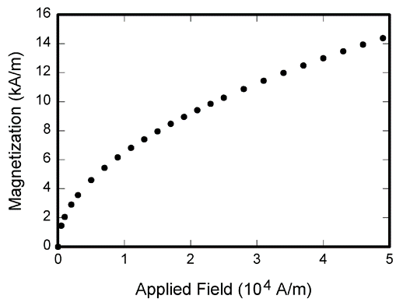
Figure 1 Resultant Graph of the Proposed System
Column Name 1 | Column Name 2 | Column Name 3
10 | 40 | 70
20 | 50 | 80
30 | 60 | 90
Table 1 Modelling Table
All the tables should be presented as shown above.

(1)

All the mathematical equations should be numbered as shown above.

- Conclusion:
The conclusion summarizes the key findings and constructive outcomes derived from the proposed system. It should not replicate the abstract and must be clearly and effectively structured to reflect the significance of the results.
- References:
- X. Xuan, J. He, P. Chai, A. E. Basabi, and G. Liu, “Kalman filter algorithm for security of network clock synchronization in wireless sensor networks,” Mobile Information Systems, vol. 2022, Article ID 2766796, p. 11.
- P. J. Chao, G. B. Hu, and L. T. Wan, “A novel sparse array configuration with low coarray redundancy for DOA estimation in mobile wireless sensor network,” Mobile Information Systems, vol. 2021, Article ID 1362640, p. 8.
- J. Wang, Y. Gao, W. Liu, A. K. Sangaiah, and H. J. Kim, “Energy efficient routing algorithm with mobile sink support for wireless sensor networks,” Sensors, vol. 19, no. 7, p. 1494, 2019.
- J. Wang, H. Han, H. Li, S. He, P. K. Sharma, and L. Chen, “Multiple strategies differential privacy on sparse tensor factorization for network traffic analysis in 5G,” IEEE Transactions on Industrial Informatics, vol. 18, no. 3, pp. 1939-1948, 2022.
- K. Vijayalakshmi and P. Anandan, “Global levy flight of cuckoo search with particle swarm optimization for effective cluster head selection in wireless sensor network,” Intelligent Automation & Soft Computing, vol. 26, no. 2, pp. 303-311, 201

